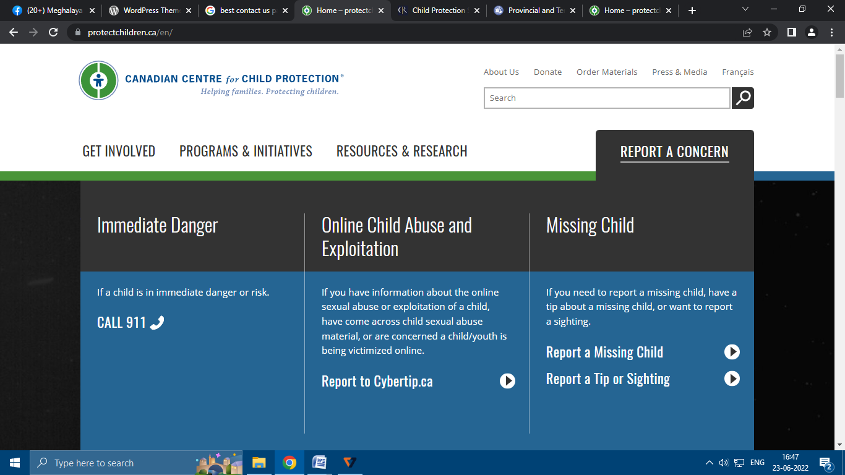

* **[ TAB 1 ]Emergency Services**
  + **Child** **Helpline** – **1098**
  + **Ambulance** – **108**
  + **Police** – **112** / **100**
  + **State Emergency Operation Centre – 1070**
  + **Women Helpline – 181**
* **[TAB 2] Child Abuse and/or Exploitation**
  + **If you have credible information about abuse or exploitation of a child, or are concerned a child/youth is being victimized. If you have credible information about abuse or exploitation of a child, or are concerned a child/youth is being victimized. If you have credible information about abuse or exploitation of a child, or are concerned a child/youth is being victimized.**
* **( call icon and email icon redirected to contact oaf=ge** 
  + **Report to MSCPCR ( landline and email button)**
* **[TAB 3] Related Services**
  + **Anti Human Trafficking Unit (AHTU) Shillong** 0364-2226185
  + **CM Connect – 1971**
  + **Sustainable Transport and Efficient Mobility Society (STEMs)-** 03643500097, 03643500098
  + **Meghalaya State Legal Services Authority -** 0364-2501051
  + **Cybercrime –**1930
  + **You can also contact District Child Protection Officers in their offices across all districts**